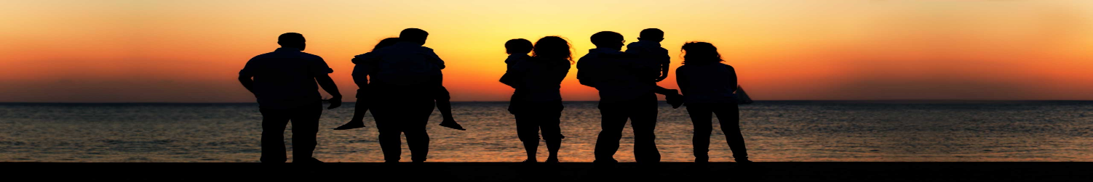

LOGO

|  |  |  |  |  |
| --- | --- | --- | --- | --- |
| ***All India*** | ***Zone Wise*** | ***States Wise &***  ***union territories*** | ***Special Places*** | ***7 Wonders in India*** |
| ***Historical Places*** | ***Nature Places*** | ***Enjoying Places*** | ***God Temples*** | ***Seasonal Places*** |